Thomas Lumley: Survival of the fittest
The figures tell us patients whose cancer is caught early live longer, but what does that really mean?
Since 1980, your chance of surviving five years after a heart attack has increased from just over 70% to just under 80%. For breast cancer, the five-year survival rate has gone from about 60% to about 85% in the same period of time, and for melanoma it has risen from about 80% to over 90%.
From these figures you might conclude that breast cancer treatment has improved a lot, treatment for melanoma has not improved as much and treatment for a heart attack has improved slightly less than for melanoma. It’s actually a bit more complicated than that.
A heart attack happens at a clear, definite point in time and it’s easy to count how many people are still alive five years later. The only way to improve five-year survival statistics for heart attack is for more people to be alive for longer. Improvements in survival are always real improvements.
A tumour starts off as a mutation in a single cell and grows over a period of years or decades. We have no way of knowing when the tumour started growing, so we can’t measure survival from that point. The only feasible option is to measure survival from the time the tumour is detected, so that is what we do.
Survival from diagnosis will increase if better treatment leads to people dying later, but survival from diagnosis will also increase if people die at the same time but are diagnosed earlier. Every month of earlier diagnosis automatically means a month of increased survival after diagnosis, even if nothing else changes.
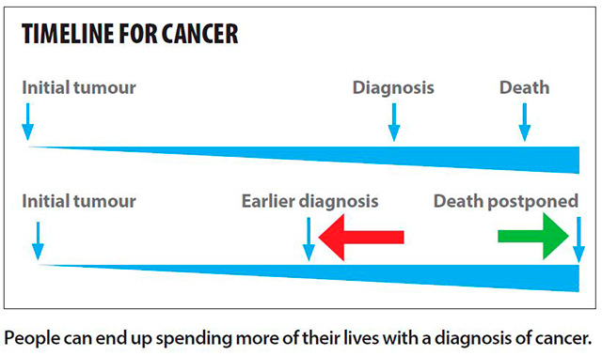Improvements in survival can be real improvements, but it’s also possible that people are living for the same time but spending more of their lives with a diagnosis of cancer.
How can we separate out the real improvements in survival from mere diagnosis bias? It’s extremely hard. Sometimes survival improves so much that the conclusion is obvious from death rates. For example, Pap smear screening is followed by a large drop in deaths from cervical cancer wherever it is introduced. Sometimes, as in childhood cancers, the increase in survival is longer than the early-diagnosis bias could possibly be.
In most cancers we aren’t sure how much of the increase in survival is real. In melanoma, for example, there has been a large increase in diagnoses but little change in deaths. Is this because early diagnosis is having no effect, or is it because early diagnosis is holding back the increase in deaths that would otherwise be happening? The truth is probably somewhere in between, but it’s hard to say where.
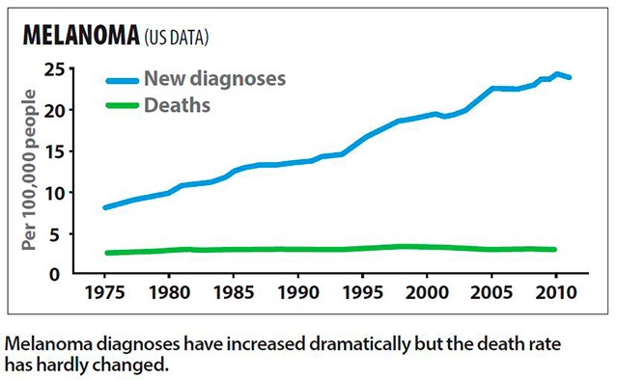In principle the problem could be solved by running randomised trials of screening, where half the people are screened and the other half not, to see whether there’s a difference in cancer deaths. These trials are expensive and difficult to run, so they aren’t available for most cancer diagnostics.
Because of the expense and for ethical reasons, the trials tend to stop as soon as they demonstrate there is a difference between the two groups. They usually can’t run for long enough to capture the full benefit of a screening programme, and so they tend to underestimate the benefit of screening.
A common slogan in cancer is that early diagnosis and treatment means improved survival. When you see this slogan, remember that it would still be true if early diagnosis and treatment had no effect on the disease.
Issue 3869
3rd July, 2014

